R. Reports Menu: D. Reconciliation Report

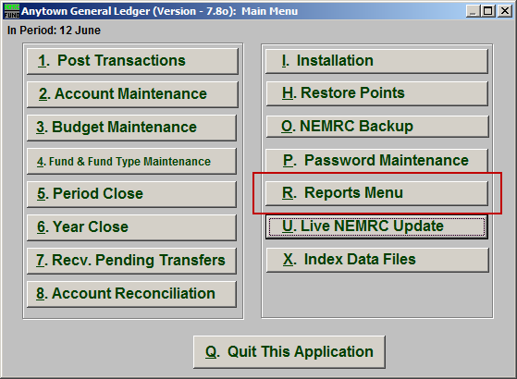
Click on “R. Reports Menu” from the Main Menu and the following window will appear:

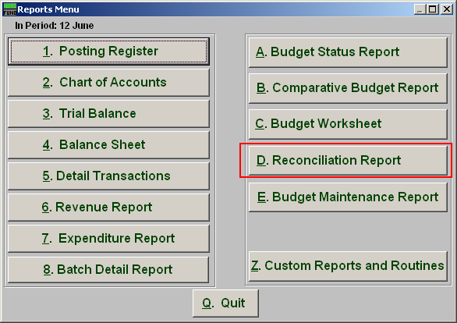
Click on “D. Reconciliation Report” from the Reports Menu and the following window will appear:

Reconciliation Report

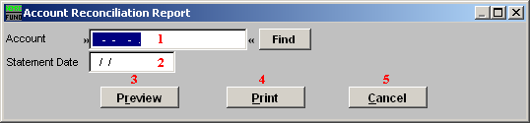
- Account: Enter the General Ledger account number that was reconciled or click “Find” and select from there.

- Statement Date: Enter the statement date for the collection of items reconciled on that date.

- Preview: Click this button to preview. Refer to GENERAL PREVIEW for more information.

- Print: Click this button to print. Refer to GENERAL PRINTING for more information.

- Cancel: Click “Cancel” to cancel and return to the previous screen.

